# Web 3 Practical – JavaScript DOM

Solve each of the following exercises using JavaScript, HTML and CSS, as required.

1. Build a JavaScript that prompts the user to enter a number. The script then then calls a function that updates the div element with id=divDisplay in the HTML file with the counting backwards from the input value to 1. So for instance, if the user inputs 6 in the prompt, your script should generate the following output in the browser through the DOM.

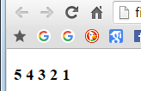

Hint: The innerHTML property of a DOM element could come in handy here

1. Another useful DOM element property is ‘style’. An element’s style is a collection of all its CSS properties. You can apply CSS rules dynamically to the element by modifying the style property. In this exercise, you are given a web page that contains a list and a button. I have specified an event handler for the button called changeTheList. Hence, you need to write a JavaScript function named changeTheList which changes the style of the list like the following images shows (clicking the button puts a border around the list, makes the width 100px and sets its background color to orange).

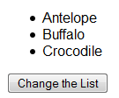 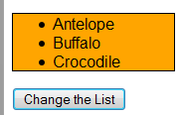

Before After

1. Replicate the functionality of exercise 2, but this time use a change in class name and take advantage of the provided CSS file.
2. The web page provided contains a button and a text box. The user types a string into the text box, and then clicks the button. When the button is clicked, the function countTxtInput() is called. Start building the countTxtInput. The output of the countVowels should be injected inside the div with #divDisplay id so that element displays the ***number of vowels*** (a, e, i, o & u) in the string input at #txtInput. Encapsulate the counting of the vowels into a function. Remember that you must count both uppercase and lowercase vowels. The output should look similar to:

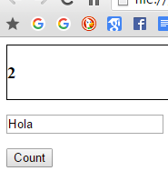

1. Write a JavaScript function **displayObjectInTable(o)**. This function accepts a single object as its input parameter and inserts the contents of that object (i.e. its key:value pairs) in the DOM in the form of a table at the bottom of the web page. You can use a simple object containing 2 teams and their corresponding scores on a game. Make sure to use methods to modify the DOM on the fly such as .createElement, .createTextNode, .appendChild. Ensure that the table is styled neatly, with collapsed borders and appropriate padding and alignment. Some sample code that could be useful to achieve the task in this exercise is given below:

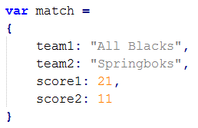

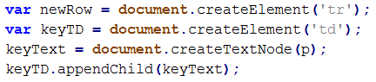

After repeatedly clicking the button 5 times, your browser should look like:

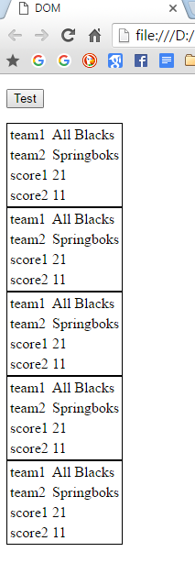

1. Use the geolocation object to retrieve the latitude and longitude of your device. Display an error message if geolocation is not available.